Software Requirements Specification
Version 3.1
Document Control
Approval
The Guidance Team and the customer will approve this document.
Document Change Control
Initial Release: | 1.0
Current Release: | 3.1
Indicator of Last Page in Document: | ∑
Date of Last Review: | 5/9/2013
Date of Next Review: | 5/10/2013
Target Date for Next Update: | 5/10/2013
Distribution List
This following list of people will receive a copy of this document every time a new version of this document becomes available:
Guidance Team Members:
Dr. Ann Gates
Omar Ochoa
Luis Garcia
Customer: Dr. Deana Pennington
Dr. Salamah Salamah
Software Team Members:
Joseph Aguirre
Andre De La Cruz
Arturo Delgado
Juan Rodriguez
Jesus Tabares
Change Summary
The following table details changes made between versions of this document

Version | Date | Modifier | Description
1.1 | 4/15/2013 | Andre | Added General Constraints, Assumptions
1.1 | 4/16/2013 | Arturo | Added Intro and Scope
1.2 | 4/20/2013 | Andre | Modified Section 2.4 and 2.5
1.3 | 4/22/2013 | Andre | Modified 3.1
1.4 | 4/24/2013 | Andre | Added section 2.3 and 2.5
1.5 | 4/25/2013 | Arturo | Added Section 1.3
1.5 | 4/25/2013 | Joseph, Juan | Added 3.1.2, added 1.4 and 4.1
2.0 | 5/1/2013 | Joseph | Addressed Omar’s comments
2.0 | 5/3/2013 | Andre | Added section 6 and addressed Omar’s comments
2.0 | 5/6/2013 | Joseph Aguirre | Added mobile requirements and revised requirements.
3.0 | 5/7/2013 | Joseph, Juan, Andre | Addressed comments from Omar
3.1 | 5/9/2013 | Joseph, Juan, Andre, | Addressed comments from Omar
Table of Contents
Document Control ii
Approval ii
Document Change Control ii
Distribution List ii
Change Summary ii
1. Introduction 5
1.1. Purpose and Intended Audience 5
1.2. Scope of Product 5
1.3. Definitions, Acronyms, and Abbreviations 5
1.3.1. Definitions 5
1.3.2. Acronyms 6
1.3.3. Abbreviations 6
1.4. Overview 6
1.5. References 6
2. General Description 7
2.1. Product Perspective 7
2.2. Product Features 7
2.3. Use Case Level 1 8
Figure 1: Use Case Diagram Level 1. 8
2.4. User Characteristics 8
2.4.1. Scientist 8
2.4.2. Database 9
2.4.3. General Public 9
2.4.4. Alert System 9
2.4.5. Datacenter 9
2.5. General Constraints 9
2.6. Assumptions and Dependencies 9
3. Specific Requirements 10
3.1. External Interface Requirements 10
3.1.1. Mobile Application 10
3.1.2. Main Application 11
3.1.3. Hardware Interfaces 17
3.1.4. Software Interfaces 17
3.1.5. Communications Interfaces 17
4. Behavioral Requirements 18
4.1. Same Class of User 18
4.1.1. Related Work Objects 18
4.2. Stimulus 19
4.2.1. Mobile Phone Application 19
4.2.2. Main Application 20
4.3. Related Features 22
4.4. Functional 23
4.4.1. Main Application 23
5. Non-behavioral Requirements 26
5.1. Performance Requirements 26
5.2. Qualitative Requirements 26
5.2.1. Availability 26
5.2.2. Security 26
5.2.3. Maintainability 26
5.2.4. Portability 26
5.3. Design and Implementation Constraints 26
6. Other Requirements 27
6.1. Database 27
6.2. Operations 27
6.3. Site Adaptation 27
7. Appendix A Class Diagram 28
8. Appendix B State Chart 29
9. Appendix C Data Flow Diagram (DFD) 30
10. Appendix D Use Case Scenarios 32
10.1.1. Describe Data Properties Use Case 32
10.1.2. Verify Datasets Use Case 33
10.1.3. View Datasets Use Case 38
10.1.4. Describe File Format Use Case 41
10.1.5. Analyze Anomaly Use Case 43

Introduction

Purpose and Intended Audience
The purpose of this document is to present the results of the analysis and elicitation of requirements phase. It serves as an anchor point against which subsequent steps can be justified. This document will also describe how the system should behave. The intended audience of this document is the guidance team, Dr. Pennington, and Dr. Salamah and as reference for our development team.

Scope of Product
The current system that research scientists are using to gather environmental data from various sensors across different geographical locations has been a problem for the scientist because the interface is difficult to use and the different proprietary formats that the sensor manufactures use. There has been a request by Dr. Pennington to improve the current system, which evaluates, manages, and detects anomalies. The following is an excerpt from the taped Interview of Dr. Pennington conducted by Dr. Gates and the Software Engineering Students on February 19, 2013. Dr. Gates asked Dr. Pennington about the limitations of the current system and Dr. Pennington’s response was:

“The biggest one is that it is written and design and formulated for a computer scientist. Its got a language of computer science, it got the interface that is relevant to computer science, talks about queries and codes and rules that's not the language of science. So it does what it needs to do but it is not useable by a scientist.”

Definitions, Acronyms, and Abbreviations
The following section contains a list of terms, acronyms, and abbreviations that will be used thought this document and is here to help the reader to have a deeper understanding of the work being presented here.

Definitions

TERM | DEFINITION
Alert | System sending a notification to the user to tell them of a new anomaly
Anomaly | Data that is received that is within the scope and falls outside of a pattern of a data property
Citizen Science | Citizens gathering data to research from their local area
CyberShare | Research group at UTEP
Data Property | Combination of scope and pattern
Dataset | The data retrieved from the sensors
Datum | Data that is expected from a single sensor reading
Datum Absence | The data does not exist within the specified scope
Datum Existence | The data does exist between the specified scope
Datum Universality | The data will always exist
File Formats | A standard way that information is encoded for storage in a computer file
Guest User | User with limited privileges of the system
L | Timestamp used on the left side of the Scope
Metadata | Data about the sensors
Pattern | A high-level abstraction describing a commonly occurring property about a dataset
R | Timestamp used on the right side of the Scope
Registered user | User that has all privileges for the system. (Scientist)
Relation Response | The data will appear in response to relation datum
Scientist | People doing research trying to understand the world around us. Scientist will be referred to as a user of the system through the duration of the document.
Scope | Range of data subsequence that is being evaluated
Sensor | Instrument that measures certain types of data

Acronyms
TERM | DEFINITION
GPS | Global Positioning Satellite, this is data that will contain a global latitude and longitude location on the earth.
IR | Interview Report
OS | Operating System
SDAT | Software Developers for the Advancement of Technology
SRS | Software Requirement Specification
UTEP | University of Texas at El Paso
WADS | Weather Anomaly Detection System

Abbreviations
TERM | DEFINITION
App | Application

Overview
The remainder of this document includes the general description of the system and specific requirements that are followed for developing the system. The general description will discuss product perspective, features, users, constraints, assumptions and dependencies. The product perspective will talk about where the product fits within the larger system and the functionalities that will be provided by this product. Product features will discuss different things that the system will have. In this section a use-case diagram will be presented to highlight essential features of the system. User characteristics will highlight the type of users the system was designed for. General constraints will explain the factors that constrain the options of the development team including any organizational factors, hardware limitations or safety and security considerations. Assumptions and dependencies will list the factors that if changed, will affect the requirements of the SRS of the system, assumptions made, and any dependencies of the system. The specific requirements will explore the requirements that are used as a guideline to develop the system. The requirements will be divided into subcategories external interface requirements, behavioral requirements, non-behavioral requirements and other requirements. The external interface requirements will discuss requirements for interfaces among different components and their external capabilities, including all its users, both human and other systems. The behavioral requirements will discuss specific behaviors that will be required by the system in order to be functional to the user.

References
[1] Guidance Team, "Requirements Definition," El Paso, TX, 2013.
[2] Guidance Team, “Overview of Data Properties”, 2013 ed.
[3] Guidance Team, “Data Property Examples”, February 19, 2013.
[4] SDAT(Team4), “Scientific Sensor Data Manager Interview Report”, El Paso, TX, March 23, 2013.
[5] SDAT(Team 4), “Scientific Sensor Data Manager Feasibility Report”, El Paso, TX , March 23, 2013.
[6] Memo from Dr. Pennington, Clients, El Paso, TX, May 02, 2013.
[7]Demonstration of Prototype to Dr A. Gates, Dr. D. Pennington, Dr. S. Salamah, O. Ochoa, L. Garcia, The University of Texas at El Paso, April 9, 2013.

General Description
This section is divided into six subsections. The product perspective will discuss where this product fits in the overall system. Product features will summarize the main features of the program it will also show a graph depicting the main functions and their relationship with each other. The user characteristics will identify each type of user of the system and their function in the system. The general constraints will discuss any known factors that will limit the system. Assumptions and dependencies will define the assumptions that the software team is taking into account.

Product Perspective
This product will assist scientist who are interested in data properties, which consist of a scope and pattern. These data properties with data sets from sensors will have certain protocols to detect anomalies. Detecting and monitoring anomalies is the primary feature of this system for the authorized users. Another important feature in the system is the creation and modification a data property by the authorize user. The product will address the concerns from a previous model, such as taking into account of what type of users will be utilizing the system and their perspectives.

Product Features
The system will be displayed as a web-based application where scientist and guest users will be able to view graphical representation of the data properties. Scientist will be able to monitor data properties and detect anomalies. This section will contain the use case scenarios. The system will do following:
- Display datasets as a graph (line/bar) for the general public and scientist.
- Generate an alert (via email/text) when an anomaly is detected.
- Keep a history of anomalies and data properties.
- Allow a scientist to create, save, delete, and edit a data property.
- Parse a file format from the user.
- Have features to change an email, contact, notification type, affiliation and password.
- Contain a map that displays sensors and users shall be able to zoom in, zoom out and choose a region where sensors are located.
- Have a search engine to search for a particular sensor.
- Keep track of sensor metadata, such that the scientist will have features to filter out sensors for specific information the scientist is looking for.

Use Case Level 1
The use-case models the actors of the system and the interactions between actors and the system. Each stick figure represents an actor, which is someone or something that will use the system for a purpose. The circles in the diagram represent functionalities of the system. The lines represent the interactions. A line connected to an actor and functionality indicates that the actor uses the system for such functionality.
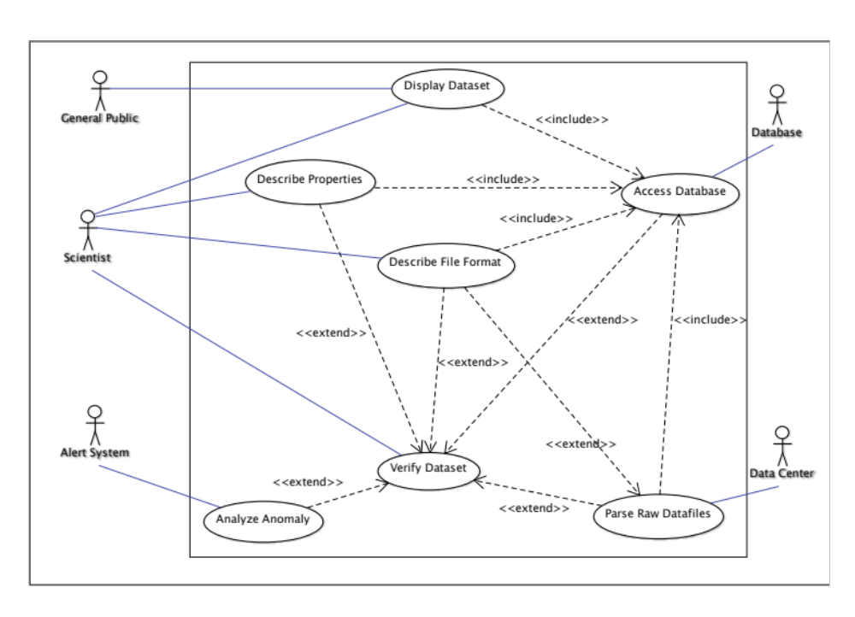

Figure 1: Use Case Diagram Level 1.

User Characteristics
This section is for describing the various types of users of the proposed system and their intended roles in the system.

Scientist
The scientists are the individuals that will use the system to retrieve data to be analyzed. They are capable of displaying datasets, which can be graphs, data from files, anomalies, or properties. However their access to information of the data may be limited to the property and data they created or were given access to by other scientist. The scientist will also need to describe the file format for external files that they want to analyze on the system. The scientist will also modify properties by creating pattern and scopes that the system will use. The scientist will also be able to set conditions for when an alert is triggered. The scientist will determine if the collected data should be accessible by the public.

Database
The database actor is the data store where all the information will be stored. It will be used to store information about the sensors and patterns such as the creator of the item as well as results from the analysis. It will be used by the system for scientist to store their properties, privileges to datasets, and alarm. It is also where saved information will be retrieved from.

General Public
The general public actor is representative of the general public that will have some limited access to the system as a part of the current trend of citizen science. The general public will only be able to view only datasets that the client will deem available to the general public, these users will not have the same privileges as a scientist and will not be able to describe a data property, describe a file format, parse a raw data file into a universal format, or verify a dataset.

Alert System
The alert system actor is the third party system that will be used to send alert messages to the scientist’s cell phones if they have configured the system to alert them via a cell phone text message. Dr. Pennington requested this feature during the first interview with the client.

Datacenter
The data center actor is used to represent a location where the data files from the sensors will be coming to the system. This actor will provide a raw data file to the system that is from a sensor and the system will then transform the file from the hardware specific file to a universal file that the system can analyze.

General Constraints
- The system must run on both Windows Vista OS and Up and Apple’s OSX operating system and up.
- The system must be accessible though the Internet.
- The system must have Internet connectivity.

Assumptions and Dependencies
This section will list any assumptions and dependencies. The development team has made the following assumptions:
- There are 4 patterns: Datum Absence, Existence, Universality, and Relation Response.
- There are 5 scopes: Global, Before R, After L, Between L and R, After L and Until R.
- A data property is dependent of a pattern, scope and a dataset; otherwise a data property cannot exist.
- A user will have a basic understanding and expertise of the dataset being observed and how it will be used.
- A null data set reading will create an anomaly.
- Measuring units will use metric system.

Specific Requirements
This section will cover the external interface and other internal requirements that the development team will adhere in order to design the system to meet the client’s needs and expectation. Furthermore, this section will cover the important features of our system that will comply with the requirements.

External Interface Requirements
This section contains the requirements and characteristics of the user interface specified by the client. This sections describes the external and behavioral requirements of the propose system. We design the user interface in respect to the requirements of the system. A scientist and a guest user will have identical external capabilities; however the scientist will have additional features to interact with the system.

Mobile Application
The following will describe the external interface requirements of the phone application.

User Interface Elements
The following will describe the user interface elements of the phone application that the user will use to interface with the system.

Main Page
The following will describe the user interface elements for the main screen of the phone application.

- The system shall contain three clickable buttons on the left side menu:
  - A button labeled “Home”.
  - A button labeled “Sensors”.
  - A button labeled “Login”.
- The system shall contain a column on the right, which contains sensor data.
- The system shall also contain the following buttons and functionalities of the non-register user:
  - A button labeled “Home”.
  - A button labeled “Sensors”.
- The system shall contain a button labeled “Preferences” in the left column.
- The system shall contain a button labeled Log out in the left column.

Login Page
The following are requirements that will describe the user interface elements of the login page.

- The system shall display ‘login’ at the top of the screen to show the user they are in the login screen.
- The system shall contain the following interface elements:
  - A label showing ‘username’.
  - A textbox for the user to enter the user’s username.
  - A label showing ‘password’.
  - A textbox for the user to enter the user’s password.
  - A button labeled ‘Submit’.
  - A button labeled ‘Cancel’.
  - A button labeled ‘Forgot Password’.
  - A button labeled ‘Forgot username’.

Tracking
The following will describe the user elements of the tracking screen.

- The Tracking screen shall contain a table with the following the following labels on the column headers:
  - Data Property.
  - Location.
  - Sensor Type.
  - Author.
- The Tracking screen shall contain the following buttons:
  - Home.
  - Back.
- The Tracking screen shall display a list of public data properties and the author’s data properties under the Data Property column.
- The Tracking screen shall display a list of the location of the sensor on the Location column associated with the data property.
- The Tracking screen shall display a list of the sensor type on the Sensory Type column associated with the data property.
- The Tracking screen shall display a list of the author on the Author column that created that specific data property.

Preferences
The following will describe the user interface elements for the preferences screen.

- The system shall contain the following buttons:
  - Password.
  - E-mail.
  - Alert Type.
  - Affiliation.
  - Side Menu Bar.

Sidebar
The following will describe the user interface elements for the sidebar interface of the phone application, this will present in all screens of the phone application.

- The system shall contain the following buttons:
  - Home.
  - Sensors.
  - Preferences.
  - Log Out.
  - Side Menu Bar.

Sensor Search
The following will describe the interface that will provide the functionality to search for a sensor to the user.

- The system shall contain the following buttons:
  - A button labeled “Search”.
  - A button labeled “Country”.
  - A button labeled “State”.
  - A button labeled “Region”.
  - A button labeled “Sub region”.
  - A button labeled “Back”.
- The system shall contain the “Search” button next to the empty textbox.
- The system shall contain the “Country”, “State”, “Region”, and “Sub region” buttons below the empty textbox.

Main Application
The following will describe the user interface elements of the various screens of the main application.

General User Interfaces
The following will describe the user interface elements that will generally appear in the main application.

- All windows shall include:
  - A minimize button.
  - A maximize button.
  - A close button at the top right corner.

Main Page
The following will describe the user interface elements of the main screen of the main application.

- The system shall contain a main page with the same layout as the sample image figure 2:
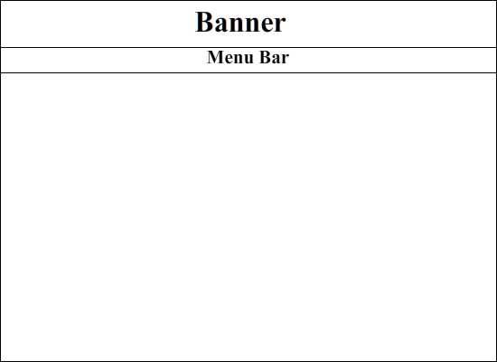
Figure 2: Sample Menu Bar Layout

- The system shall contain a main page with the following buttons:
  - A button labeled “Login”.
  - A button labeled “Proceed to Sensor Map”.
  - A button labeled “Wizard”.
- The system shall contain a “Login” button in the menu bar align to the right end of the screen.
- The system shall contain a “Welcome” text in the center of the screen below the banner explaining what the system is supposed to do and who it is designed for.
- The system shall contain a “Wizard” button on the bottom left hand side of the screen.
- The system shall contain a “Proceed to Sensor Map” button on the bottom center of the screen beneath the “Welcome”.

Wizard Training Guide
The system will have a separate component that will assist newly users how to navigate and use the system. The wizard training guide will be composed of images/icons and description to provide users instruction on how to function the system. The following requirements will describe the wizard training guide.

- The system shall contain the following interface items:
  - A button labeled ‘next’ in the ‘select a sensor’ screen allowing the user to move to the ‘specify a scope’ screen.
  - A button labeled ‘previous’ in the ‘select a sensor’ screen allowing the user to move to the previous screen.
  - A button labeled ‘exit’ in the ‘select a sensor’ screen allowing the user to exit the wizard training guide.
- The system shall contain a next button in the ‘specify a scope’ screen allowing the user to move to the ‘specify a pattern’ screen.
- The system shall contain a previous button in the ‘specify a scope’ screen allowing the user to move the ‘select a sensor’ screen.
- The system shall contain an exit button in the ‘specify a scope’ screen allowing the user to exit the wizard training guide.
- The system shall contain a next button in the ‘specify a pattern’ screen allowing the user to move to the next screen.
- The system shall contain a previous button in the ‘specify a pattern’ screen allowing the user to move to the ‘specify a scope’ screen.
- The system shall contain an exit button in the ‘specify a pattern’ screen allowing the user to exit the wizard training guide.
- In the ‘select a sensor’ screen the system shall have the previous button disabled as the ‘select a sensor’ screen is the first screen in the tutorial and there is no screen before it.
- In the ‘specify a pattern’ screen the system shall disable the next button as the ‘specify a pattern’ screen will be the last screen in the tutorial and there is no screen after to move to.

Login
The following are the user interface requirements for the login page, which will be used by registered users to log into the system to gain access to the full functionality of the system.

- The system shall contain the following interface items:
- A textbox that will allow users to enter their username.
- A textbox that will allow users to enter their password.
- A button labeled ‘submit’.
- A ‘username’ label for the username textbox.
- A ‘password’ label for the password textbox.
- A button labeled ‘cancel’.
- A button labeled ‘forgot username’.
- A button labeled ‘forgot password’.
- A button labeled ‘create user’.

Preferences
The following are the user interface requirements for the preferences screen, which will be used by the registered users to change their personal preferences.

- The preference screen shall contain the following text fields labeled:
- Email.
- Phone.
- Password.
- Affiliation.
- The preference screen shall contain the following buttons:
  - A button labeled ‘cancel’.
  - A button labeled ‘save’.
- The preference screen shall contain a drop down menu labeled "Alert Notification" with the following values:
- Email.
- Text.

Sensor Search Map
The following will describe the user interface requirements for the sensor search map, which will be used by the users to search for an area of sensors to select a specific sensor.

- The system shall display an image representing a map of the world.
- The map shall contain the following functions:
  - Zoom in/Zoom out.
  - Drag image.
  - Scrolling.
- The map shall be separated into four different zooming levels:
  - World.
  - Regions.
  - Country.
  - Section.

Tracking
The following will describe the user interface requirements for the tracking screen, which will be used by registered users to keep track of specific data properties and sensors.

- This screen will contain a list of sensors the user has identified to follow. The tracking will contain the following requirements and features.
- The system shall contain the following labeled buttons below the table:
  - A button labeled “Delete”.
  - A button labeled “Edit”.
- The system shall contain a table with a column label “Data property name” that will have the registered user specify name for property the user is tracking.
- The system shall contain a table with a column labeled “Author” which will contain the name of the original creator of the property.
- The system shall contain a table with a column labeled “Type” which will contain the type of data the sensor is measuring.
- The system shall contain a table with a column labeled “Date Created” which will contain the date the property was created.
- The system shall contain a table with a column labeled “Location” which will contain the GPS coordinates of the sensor location.
- The system shall contain a table with a column labeled “Sensor” which will contain the serial number of the sensor being tracked.
- The sub window or sub windows shall contain text fields containing name of data property, author, scope, and pattern.
- The sub window for edit shall contain the text fields already filled in with the information already created.
- The sub window for create shall contain the text fields empty.
- The system shall provide the registered user with drop down menus, which will contain different fields from the file such as date, time, sensor, and data.
- The user shall be able to specify the length of each data field through a text field below the drop down menus.
- The user shall be able to save the file once it has been formatted.

Sensor
The following will describe the user interface requirements of the sensor screen, which will be used by the users of the system to select a specific sensor from a finite sensor list.

- The system shall contain a “Back to Map” button located at the upper right hand side of the screen.
- The system shall contain a table in the center of the screen which will contain three columns:
  - A column labeled “Sensor”.
  - A column labeled “Location”.
  - A column labeled “Type”.
- The system shall contain a table that will contain a scroll bar on the right hand side of the sensor filter table.
- The system shall contain a table with the “Sensor” column that will display the serial number of the associated sensor.
- The system shall contain a table with the “Location” column that will display the longitude and latitude GPS coordinates of associated sensor.
- The system shall contain a table with the “Type” column that will display what the associated sensor measures.
- The system shall contain columns on the sensor filter table that are clickable.
- The system shall contain rows on the sensor filter table that are clickable.
- The system shall contain a combo box on the right of the table that will contain the selectable options:
  - An option labeled “Filter”; “Filter” shall be the default selection.
  - An option labeled “Sensor”.
  - An option labeled “Location”.
  - An option labeled “Type”.
- The system shall contain a text box beneath the combo box where the user can type text that the user would like to filter by.
- The system shall display a sub window to prompt the user for a range of time that data was collected on a selected sensor.

Data Properties
This screen will contain the data properties the user has developed and other users that have allowed the user login to see. The data property screen contains a list of data properties, a section to define a scope, anomalies and a graph that visualizes the data property.
- The system shall display a list of public data properties from other users for other users to view, modify and edit.
- The system shall list anomalies associated with the data property.
- The system shall contain the name of the system at the top center of the main screen.
- The system shall contain a menu bar on the top upper end but below of the screen.
- The system shall contain a “Home” button in the menu bar located on the left end.
- The system shall contain a “Sensors” button in the menu bar located to the right of the “Home” button.
- The system shall contain a “File Format” button in the menu bar located to the right of the “Sensors” button.
- The system shall contain a “Preference” button in the menu bar located to the right of the “File Format” button.
- The system shall contain a “Logout” button in the menu bar located on the right end.
- The system shall contain a list of the data properties previously created located on the left side of the screen below the menu bar.
- The user shall have the option to select a data property from the list.
- The system shall contain a list of all the data properties previously created by the user and from other user that created data properties, which will be public.
- The system shall contain a graph that displays a data property visually. It shall be located in the center of the screen below the menu bar. The graph can be a line graph, a bar graph or a pie chart.
- The system shall contain a list of the anomalies located on the right side of the screen below the menu bar.

Data Property List
This screen will contain the data properties list the user has developed.

- The system shall contain a list data properties created by the user. The data property list shall contain the following items:
  - Data properties created by the user throughout the duration of using the system, unless the data property is deleted.
  - Public data properties created by other users.
- The user shall be able to click on data properties on the list.
- The system shall display a screen similar to the following figure presented below to the user to specify and detect anomalies.

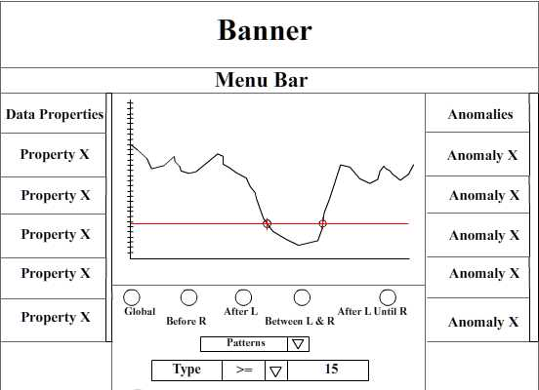
Figure 3: Sample data properties analysis screen

Anomaly List
The following will describe the user interface requirements of the anomalies list depicted in the above figure.

- The system shall contain a list of the anomalies located on the right side of the screen below the menu bar.
- The user shall be able to click on anomalies on the list.

Setting up a Scope
The following will describe the user interface requirements of the interface that provides the users with the functionality to set up a scope in a selected dataset.
- The system shall contain a radio button that corresponds to the “Global Scope”. It shall be located below the graph.
- The system shall contain a radio button that corresponds to the “Before R” scope. It shall be located below the graph.
- The system shall contain a radio button that corresponds to the “After L” scope. It shall be located below the graph.
- The system shall contain a radio button that corresponds to the “Between L & R” scope. It shall be located below the graph.
- The system shall contain a radio button that corresponds to the “After L until R” scope. It shall be located below the graph.

Setting up Pattern
The following will describe the user interface requirements of the interface that provides the users with the functionality to set up a pattern in a selected dataset.

- The system shall contain a “scroll down” menu, which contains all selectable patterns available to the user. This menu shall be located below the radio buttons.
- The system shall contain a “scroll down” menu, which contains the type of data being measured. The type can be temperature, humidity, among others.
- The system shall contain a “scroll down” menu, which contains the following mathematical relational symbols:

Definition | Symbol
Less than | <
Greater than | >
Less than or equal | <=
Greater or equal | >=
Equal | =

- The “scroll down” menu shall be located below the “Patterns” “scroll down” menu and to the right of the “Type” scroll down” menu.

Hardware Interfaces
No requirements related to this section have been specified.

Software Interfaces
The following section will discuss the different software the system will interact.

- Application will execute on Microsoft Windows with the following Operating System.
- Windows 8.
- Windows 7.
- Windows Vista.
- Windows XP.
- Application will run on Apple Mac with the following Operation System:
- OS X – Mountain Lion.
- OS X – Lion.
- OS X – Snow Leopard.
- The system shall use SMS to send text message alerts to registered user’s cell phones.
- The system shall use SMTP to send email alerts to registered user’s email addresses.

Communications Interfaces
No requirements related to this section have been specified.

Behavioral Requirements
The following section will describe how the system will describe the requirements that describe how the system will perform in a general sense.

Same Class of User
The system has three types of users, the scientist, the general public, and the administrator. Scientist has access to all the features of the system.

- The system shall have two levels of privileges: Registered User and Guest User.
  - Registered – Scientist who is registered in the system.
  - Guest User – General public, Citizen Scientist.
- The system shall have a login window for registered user.
- Registered user shall have access to all features of the system.
- General public shall be able to view public data properties.
- The system shall have the general public users with restricted access that will not be able to create/edit properties.
- The system shall have an administrator that will be managing the data and the properties.
- The system shall inform the user about the precision and accuracy of the sensor measurement in the table of sensors available for the user to select to analyze.

Related Work Objects
The object model for our system is provided in Appendix A. The class diagram depicts the entities modeled by the system and the relationships among them. This section describes the requirements related to the main objects of the system.

- A data property shall be composed of a pattern and scope.
- The scopes of the system shall be composed of the following:
- Global.
- After L.
- Before R.
- Between L & R.
- After L Until R.
- The patterns of the system shall be composed of the following:
- Datum Absence.
- Datum Universality.
- Relation Response.
- Datum Existence.
- The system shall have the functionality that will take the raw data files from the sensor and will translate them into a universal format that the system will be able to work with.
- The system shall have the functionality that will visualize the translated data from a selected sensor.
- Once a data property (a scope and pattern) has been specified in relation to a dataset from a sensor the data property shall generate the anomalies.
- The scientist shall be a type of general public user.
- The scientist shall perform the following with respect to describing file formats:
- Create a file format.
- Edit a file format.
- Delete a file format.
- The parser or the translation functionality shall depend on the file format description from the user to translate the raw data files from the sensor.
- All general public users (including scientist users) shall be able to see the parsed or translated data files (raw numeric data).
- All general public users (including scientist users) shall be able to view a graphical form of the datasets.

Stimulus
The following are stimulus requirements or requirements on how the system will react to user input or interactions, such as what will the system do when a button is pressed.
The state chart model for our system is provided in Appendix B.

Mobile Phone Application
The following will describe the requirements of how the system will respond to interactions with the user who is interacting with the system though the mobile phone application.

Main Page
The following will describe the requirements of how the system will respond to the user’s interactions on the mobile phone application’s main screen.

- When the user clicks on the login button the system shall take the user to the login screen.
- When the user clicks on the guest button the system shall take the user to the search sensor screen.

Login Page
The following will describe the requirements of how the system will respond to the user’s interactions on the mobile phone application’s login screen.

- When the user clicks on the username textbox the system shall display the keyboard and allow the user to enter their username in the textbox.
- When the user clicks on the password textbox the system shall display the keyboard and allow the user to enter their password in the textbox.
- When the user clicks on the cancel button the system shall take the user back to the homepage.
- When the user enters their password the system shall display the characters in the password textbox as a series of dots.
- When the user clicks on the submit button the system shall verify the user-supplied username and password.
- When the user clicks on the submit button for the system to verify the login information the system shall encrypt the information before transmitting to the database to verify the data.

Tracking
The following will describe the requirements of how the system will respond to the user’s interactions on the mobile phone application’s tracking screen.

- When a data property is selected the tracking screen will be able to:
- Add a data property.
- Edit a data property.
- Delete a data property.

Preferences
The following will describe the requirements of how the system will respond to the user’s interactions on the mobile phone application’s preferences screen.

- When the user clicks/taps on the Password button the system shall take the user to the Password screen.
- When the user clicks/taps on the E-mail button the system shall take the user to the Password screen.
- When the user clicks/taps on the Alert Type button the system shall take the user to the Password screen.
- When the user clicks/taps on the Affiliation button the system shall take the user to the Password screen.
- When the user clicks/taps on the Side Menu Bar button located on the top left corner, the system shall slide a bar across the screen with four buttons: Home, Sensors, Preferences, and Log Out.

Sidebar
The following will describe the requirements of how the system will respond the user’s interactions on the mobile phone application’s side bar screen, which will be available to all screens in the mobile phone application.

- When the user clicks/taps on the Home button the system shall take the user to the Home screen.
- When the user clicks/taps on the Sensors button the system shall take the user to the Sensors screen.
- When the user clicks/taps on the Preferences button the system shall take the user to the Preferences screen.
- When the user clicks/taps on the Log Out button the system shall take the user to the Log Out screen.
- When the user clicks/taps on the Menu Side Bar button, the system shall go back to the screen where the Menu Side Bar button was originally clicked/tapped.

Alerts
The following will describe the requirements pertaining to the alerts.

- The system shall display info about the anomalies if the user clicks on an alert.
- The system shall alert the user when an anomaly occurs.

Main Application
The following will describe the requirements of how the system will respond to the user’s interactions on the various screens of the main application.

- The system shall display on an alert screen.

Training Wizard
The following requirements are the stimulus requirements that have to do with the user interaction in the training wizard functionality.

- When the wizard training guide button is pressed the system shall display a screen that will instruct the users on how to properly select a sensor though images, icons, and text explaining what the user must do in order to narrow down the sensor list and select a sensor they wish to view.
- When the next button is pressed from the ‘select a sensor’ screen the system shall display a screen that will instruct the users on how to specify a scope though images, icons, and text explaining what the user must do in order to properly set a scope or a point of interest in the selected sensor’s dataset.
- When the previous button is pressed in the ‘specify a scope’ screen the system shall display the screen for how to select a sensor.
- When the next button is pressed the system shall display a screen on how to specify a scope screen the system shall display a screen that will instruct the users on how to specify a pattern though images, icons and text explaining what the user must do in order to specify a pattern to be applied to a selected sensor’s dataset.
- When the previous button is pressed the system shall display the instructions on how to specify a scope.

Login
Following are stimulus requirements that have to do with the user interaction in the login functionality.

- When the user clicks on the submit button the system shall verify the user inputted username and password are correct by comparing the supplied username and password against the saved username and password in the database.
- When the user clicks on the cancel button the system shall close the login screen sub window and return to the main page.
- If the user inputted username and password is incorrect the system shall display a login error message.
- When the user clicks on the forgot username button the system shall prompt the user to enter their email address to have their username sent to their email.
- When the user clicks on the forgot password button the system shall prompt the user to enter their email address to have their password sent to their email.
- When the user clicks on the create user button the system will prompt the user to enter their email address, username, password, affiliated institution, and name.
- If the user inputted username and password is verified the system shall log the user into the system and displays the tracking page.

Preferences
The following will discuss the requirements pertaining to the preference.

- A user shall be able to update the following information from the Preference screen:
- Email Address.
- Phone Number.
- Alert Notification.
- Affiliation.
- The system shall verify the email entered is valid.
- The system shall verify phone entry has 10 digits.

Main Page
The following will describe the requirements of how the system will react to the user’s interactions on the main screen on the main application.

- When the user clicks “Home” the system shall redirect to the home screen.
- When the user clicks “Sensors” the system shall redirect to the Sensor screen.
- When the user clicks “Login” the system shall redirect to the login screen.
- When the user clicks “Preferences” the system shall redirect to the preference page.
- When the user clicks “Log-out” the system shall redirect to the home screen, ending the login session.

Select A Sensor
The following will describe the requirements of how the system will react to the user’s interactions on the select a sensor screen on the main application.

- When the “Search” button is clicked the system shall search the database for the text in the textbox, displaying the sensor number, location, and type.
- When the “Country” button is clicked the system shall display a list of countries where sensors are located.
- When the “State” button is clicked the system shall display a list of states, within the selected country, where sensors are located.
- When the “Region” button is clicked the system shall display a list of regions, within the selected state, where sensors are located.
- When the “Sub region” button is clicked the system shall display a list of sensors associated to the sub region.
- When the “Back” button is pressed the system shall redirect to the main page.
- When the user selects a sensor the system shall prompt the user to enter a range of time that data was gathered from the sensor.

Data Properties
The following will discuss requirements of the data properties.

- When a user clicks on an anomaly alert the system shall display an sub window with more detailed information about the alert with the following information:
- Data property used.
- Dataset that triggered the anomaly.
- Timestamp of anomaly.
- When the “Home” button is clicked, the system shall redirect to the original home page. The original home page is the first screen after the credentials have been approved.
- When the “Sensors” button is clicked, the system shall redirect to a new page with the list of the sensors.
- When the “File Format” button is clicked, the system shall redirect to a new page where the user can select a format to download anomalies found by the system. (Pending feedback from the client)
- When the “Preferences” button is clicked, the system shall redirect to the “Preferences” page.
- When the radio button “Global Scope” is chosen, it is shaded black and no other radio button is selected. The graph will change according to the new scope value. By default, the system will display the values of the last data property created.
- When the radio button “Before R” is chosen, it is shaded black and no other radio button is selected. The graph will change according to the new scope value. By default, the system will display the values of the last data property created.
- When the radio button “After L” is chosen, it is shaded black and no other radio button is selected. The graph will change according to the new scope value. By default, the system will display the values of the last data property created.
- When the radio button “Between L & R” is chosen, it is shaded black and no other radio button is selected. The graph will change according to the new scope value. By default, the system will display the values of the last data property created.
- When the radio button “After L until R” is chosen, it is shaded black and no other radio button is selected. The graph will change according to the new scope value. By default, the system will display the values of the last data property created.
- When a value is selected from the “Patterns” “scroll down” menu, the graph will change according to the new pattern value. By default, the system will display the values of the last data property created.
- When a value is selected from the relational mathematical symbols “scroll down” menu, the graph will change according to the new relational symbol value. By default, the system will display the values of the last data property created.
- When a data property from the list of data properties is clicked, a pop-up window will appear, showing the description of that data property. It shall have the date it was created, scope and pattern values, and the name of the author.
- When an anomaly is clicked, a pop-up window will appear, showing the description that anomaly.
- The user shall have the option to view the information that states what error was caused when a problem or anomaly was raised and will include the data property that was used and the data set is associated with the data property.

Sensor Search
The following will discuss requirements pertaining to the sensor search.

- When the “Back to Map” button is press the system shall redirect to the map of sensor locations.
- When the heading of one of the columns is clicked the system shall sort the table based on the items of the clicked column.
- When a row of data on the table is clicked the system shall redirect to the “develop data properties” page passing the clicked sensor serial number.
- When an item other than “filter” is selected from the combo box and text is inputted into the text box the system shall search the selected column for the typed text, displaying all sensors that meet the condition and region of interest.

Tracking
The following will discuss requirements pertaining to the tracking.

- The system shall display sub window based on the command selected.

File Format
The following will discuss requirements pertaining to the file format.

- The scientist shall have the option to format a data file, which will contain available raw information coming from the sensors.

Related Features
The following will describe the miscellaneous added features of the system.

- The system shall give a user the ability to download visual graphs; line and bar graph.
- The system shall give a user the ability to print a visual graph; line and bar graph.
- The system shall give a user the ability to have data properties to be displayed in a graphical representation: line or bar graph.

Functional
Functional requirement specify actions in the system. This includes accepting and processing inputs and generating results for the user. A data flow can demonstrate the relationships between the functions and data input. A data flow diagram is provided in Appendix B to demonstrate the main use of the system.

- The system shall give the user the ability to export the data files they are viewing as a choice of a text file or a PDF file.
- The system shall give the user the ability to import data from data files for the system to analyze.
- The system shall compare the values from the data file from the sensor to the user specified pattern, within the user specified scope.
- If a dataset is not continuous the system shall display and error warning describing to the user that the information is not continuous and will give the user the option to graphically merge the pieces of the graph together.
- In the ‘Before R’ scope if the R the user has specified has not occurred yet the system shall keep adding the information and depicting it graphically until the specified R occurs.
- In the ‘Before R’ scope if the R the user has specified has not occurred yet the system shall display an error message describing that the R the user has specified has not occurred yet and will continue to fetch information until R has occurred.
- In the ‘After L’ scope if the user has entered an L value that doesn’t exist the system shall display an error message describing to the user that the L value doesn’t exist.
- In the ‘Between L & R’ scope if the user specifies an R that hasn’t occurred yet the system shall display an error message describing that the specified R hasn’t occurred yet and the system will keep fetching data until the specified R has occurred.
- In the ‘Between L & R’ scope if the user specifies an L that doesn’t exist the system shall display an error message describing that the specified L doesn’t exist.
- In the ‘After L & Until R’ scope if the user specifies an R that hasn’t occurred yet the system shall display an error message describing that the specified R hasn’t occurred yet and the system will keep fetching data until the specified R has occurred.
- In the ‘After L & Until R’ scope if the user specifies an L that doesn’t exist the system shall display an error that describes that the specified L doesn’t exist.

Main Application
This section will have the requirements of the main system.

Login
The following requirements are the functional requirements of the login functionality.

- The system shall mask the user’s password input into the password textbox as a series of black dots.

Scope
The following requirements are the functional requirements that are associated with scopes. Scopes is a component that will make up a data property. The client has identified 5 scopes for our system, described in Section 1.3 of the SRS.

- The system shall with the ‘After L’ include the data readings starting from where L holds.
- The system shall with the ‘Before R’ scope include the data readings up to where R holds.
- The system shall with the ‘Before R’ scope not include where R holds.
- The system shall with the ‘between L & R’ include the reading starting from where L holds up to where R holds.
- The system shall with the ‘Between L & R’ scope not include where R holds.
- The system shall with the ‘After L Until R’ scope include the data readings starting from where L holds up to where R holds.
- The system shall with the ‘After L Until R’ scope not include where R holds.
- The system shall build a scope once L and/or R is defined.
- The system shall with the ‘Global’ scope present all available data for the selected sensor.

Pattern
The following requirements are the functional requirements that are associated with patterns. Pattern is a component that will make up a data property. The client has identified 4 patterns for our system which is described in Section 1.3 of the SRS.

- The system shall with the ‘Absence’ pattern selected, check that the condition within the defined the scope does not hold.
- The system shall with the ‘Existence’ pattern selected, check that the condition within the defined scope does hold.
- The system shall with the ‘Response’ pattern selected, check that a sensor’s reading responds to another sensor’s reading.
- The system shall with the ‘Universality’ pattern selected, check that a senor’s readings hold.

Data Properties
The following requirements are the functional requirements that are associated with data properties. User can develop properties by selecting a pattern and scope. The dataset will be read according the specification of the data property.

- The system shall give users the ability to reuse data properties and save it as their own.
- The scientist shall have the option to edit data properties.
- The scientist shall have the option to compare sensors measuring different units for relation pattern.
- The scientist shall have the option to enable or disable an anomaly alert.
- If a data property has ben shared publicly the user shall not have the option to remove the data property.
- The un-registered or guest users shall not have the option to:
  - Create new data properties.
  - Delete data properties.
  - Modify data properties.
- The System shall give the users the ability to reuse data properties.
- The scientist shall have the option to choose the type of notification they would like, from email or mobile alert.
- The system shall give the users the ability to perform a comparison between sensors in different locations or measuring different units.
- The system shall create an alert (email alert and/or cellular text message) when data is outside the user’s specified condition within the data property to inform the user when an anomaly occurs.
- The user shall have the option set the frequency of which the data stream measures in minutes, seconds, hours, or microseconds.
- The system shall inform a user when units are not the identical when applying data properties.
- The system shall display appropriate units based on the datasets. (For instance, humidity = percentage, temperature = Celsius)

File Format
The following will describe the functional requirements of the file format screen on the main application.

- The system shall take the different sensor file formats and convert them to a system-standardized format for analysis.
- The system-standardized format shall be structured as follows:
<Sensor Serial Number> <GPS Coordinates> <Precision & Accuracy Of Sensor> <Unit Type> <Temporal Frequency> <Date> <Timestamp> <Data>.
- The system shall store newly created file formats to be used to parse new types of data files coming from new sensors.

Tracking Page
The following will describe the functional requirements of the tracking screen on the main application.

- The system shall give scientists the ability registered users to add data properties to a personal tracking list.
- The system shall give scientists the ability user to copy a data property.
- The system shall give scientists the ability to click on a data property and view data in a graph.
- The system shall give scientists the ability to search through the data property via search bar.
- The copy command shall copy all the current existing data from a data property with the exception of the author, which will be changed according to the user logged in.

Non-behavioral Requirements
The section will discuss the performance and qualitative characteristics of the system.

Performance Requirements
The following will describe the requirements that specify how the system will execute.

- The system shall be able to support a user to be logged in in three different places such as a desktop computer, a laptop computer, and a cell phone.
- The system shall be able to support at least 10 users logged on to the system concurrently.

Qualitative Requirements
The following are requirements that will describe performance characteristics of the system.

Availability
The following will describe the requirements that specify how widely available the system will be to the users.

- If the system encounters an error the system shall continue to collect the data being streamed in from the sensors.
- The system shall be continuously available though the web interface as long as the server handling web interface remains operational.

Security
The following will describe the requirements that specify how secure the system will be in terms of how well protected information such as login information, data, etc.

- The system shall encrypt the registered user’s information.
- If a user is inactive for longer than 20 minuets then the system shall automatically log the user out of the system.

Maintainability
At this time proper requirements pertaining to maintainability can not be specified.

Portability
The following will describe the requirements on portability of the system.

- The system shall be available on windows computers operating on windows vista operating system and later.
- The system shall be available on Apple computers operating on Mac OS X operating systems and later.

Design and Implementation Constraints
No design and implementation constraints are specified at this time.

Other Requirements
This section will have the requirements that are not UI or functional related to the system, but a critical component for the system to function properly.

Database
The following will describe the requirements for the database system.

- The system shall have access to modify, delete, and add to a database.
- The system shall check the incoming data in the data files against the previously stored data in the database to ensure the integrity of the data coming in.
- The system shall store the following information for each registered user:
- Full Name.
- Title.
- Position.
- Institution.
- E-mail.
- And phone number.
- When a user saves a data property the system shall store the following information along with the data property:
- Author.
- Data created.
- Date modified.
- Modifier’s name.
- The system shall store a version control on data property modification.
- The data properties shall be able to be applied to collected historical data.
- The system shall store three kinds of data; data that is coming off the sensors, data properties, and anomalies.
- The system shall store the most recent alerts.

Operations
The following will describe characteristics of the system that is not visible or controlled by the user.

- The system shall send a second email/text if anomaly has not been addressed by the author tracking the data property that generated the anomaly within 24 hours.
- The system shall have automatic backups every 48 hours.
- When all fields are filled, a user can save changes.

Site Adaptation
No site adaptations have been specified at this time.

Appendix A Class Diagram

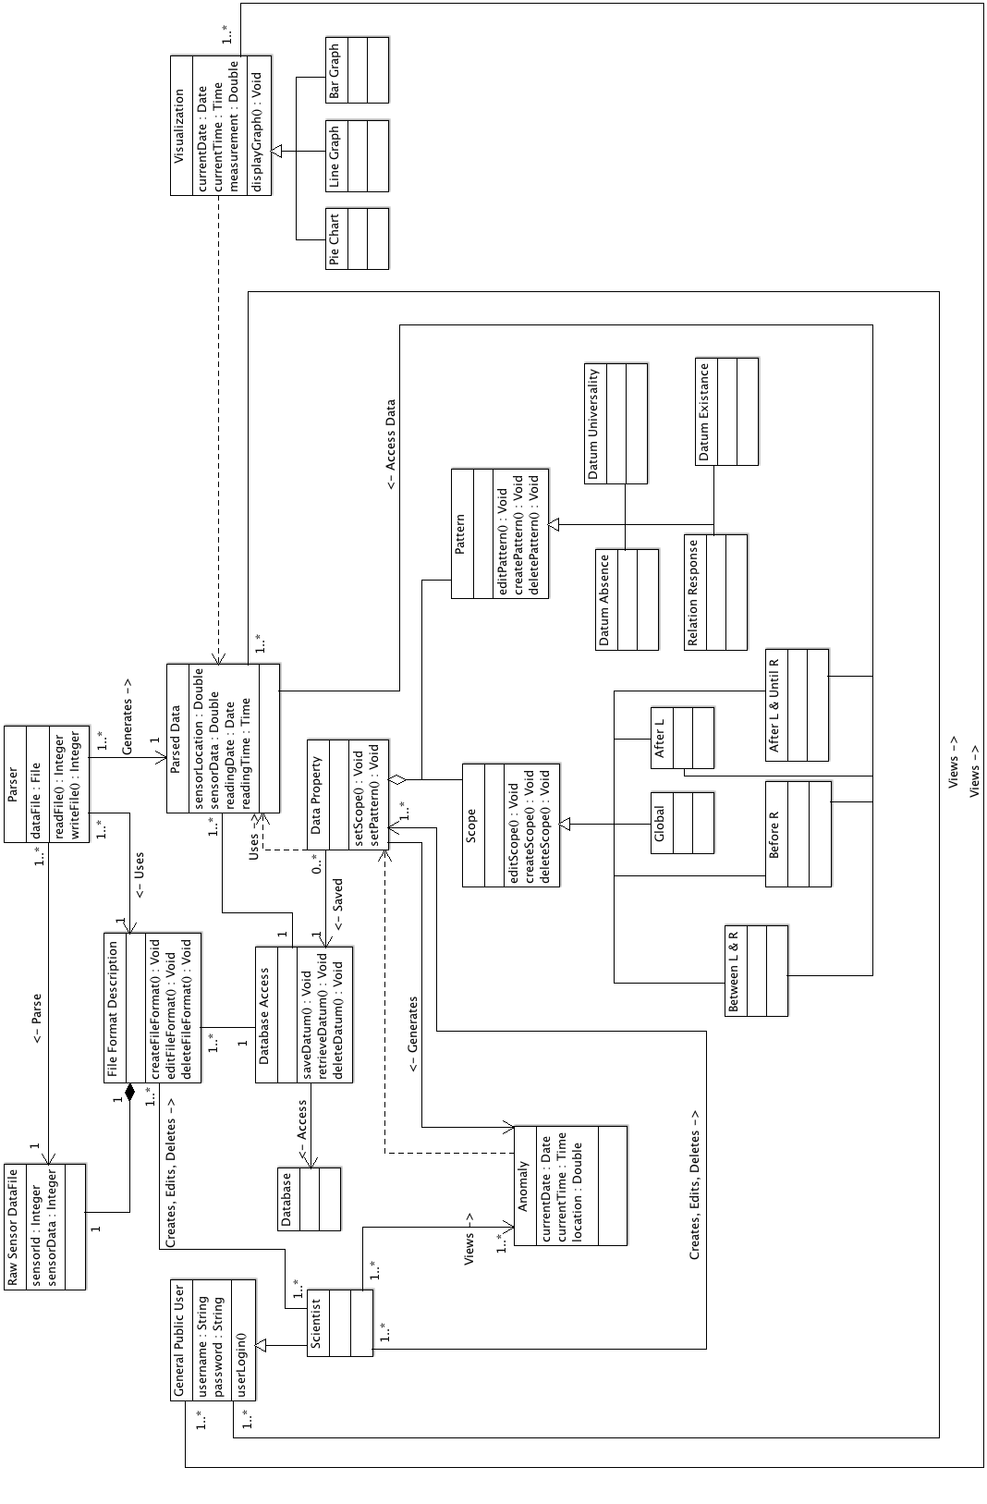

Appendix B State Chart
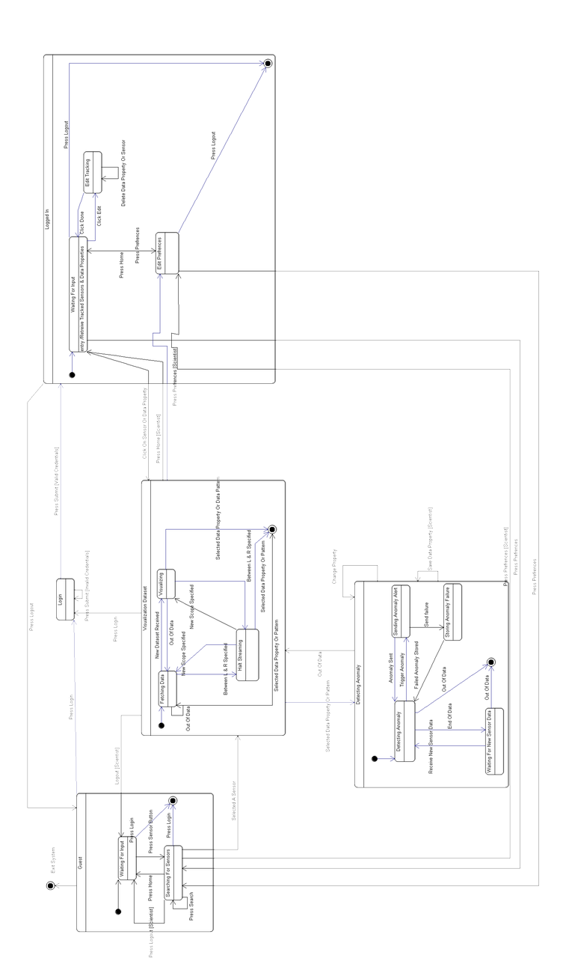

Appendix C Data Flow Diagram (DFD)
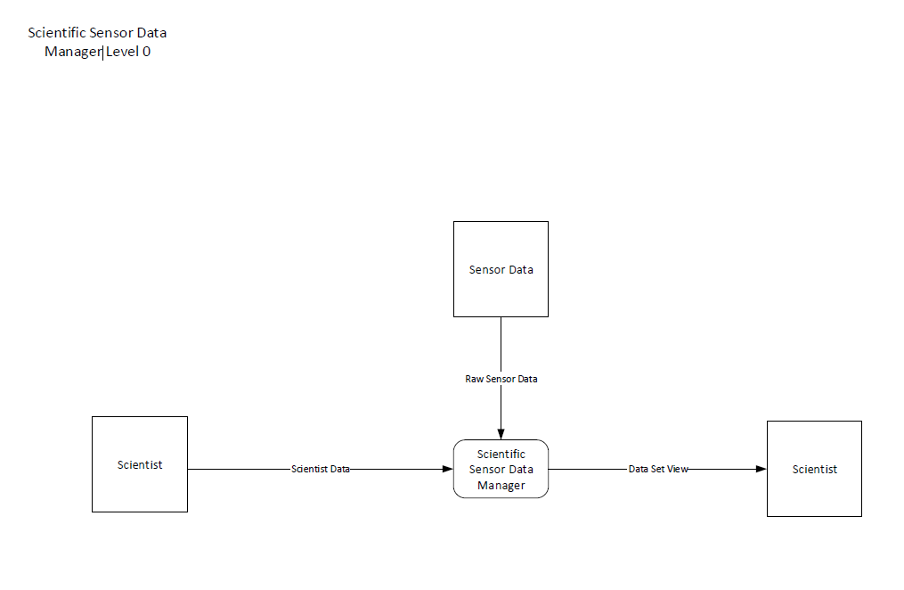
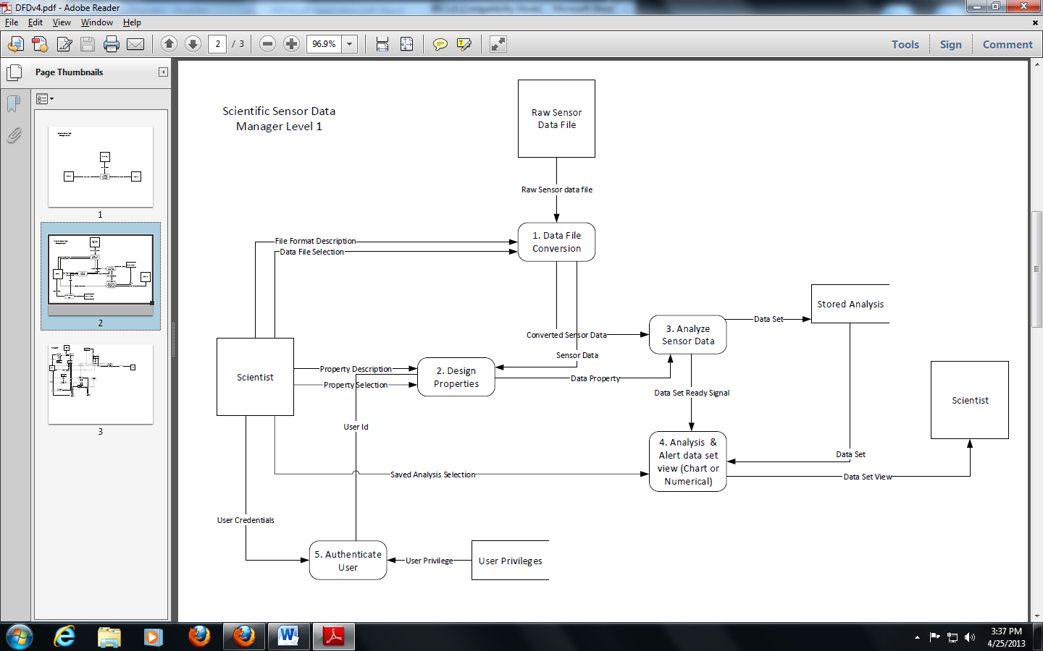

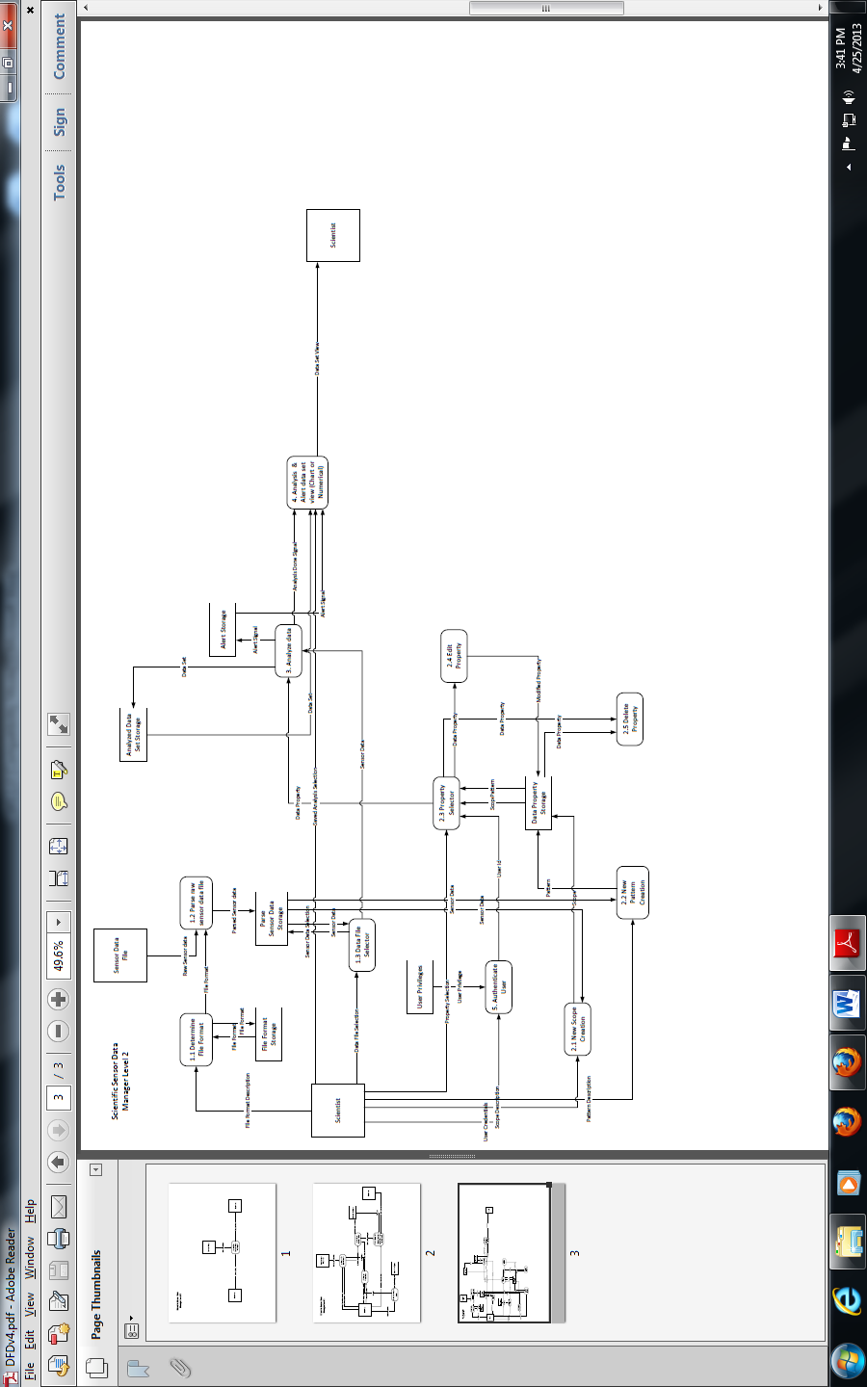

Appendix D Use Case Scenarios

This section describes the various uses of the system from the view of the various users of the system.

Describe Data Properties Use Case
Scenario 1: Create A New Data Property.
Include Use Case: Access Database.
Description: The Scientist describes a new data property to be saved to the database for later use.
Actors: Scientist, Database.
Pre-Condition: The scientist has logged on to the system and the scientist is a registered user of the system.
Trigger Condition: The scientist has chosen the option to describe a new property.

- The system displays a form where the scientist can specify a scope, a pattern, a data file they wish to associate the data property with, and any other general comments he/she may have.
- The scientist selects the save data property option.
- The System accesses the database.
- The database stores the user specified data property along with the scientist’s general information (i.e. name, number, place of study at the time, etc.) (Alt 1).
- The system informs the user that the property has been saved to the database.
- End of use case.

Alt 1: Property created already exists.
- The database generates a message to the system signifying that the specified data property already exists in the database.
- The system generates a message to the scientist that the specified data property already exists in the database and asks the user if they wish to view the property in the database.
- The scientist choses the option to view the data property (Alt 2).
- The system accesses the database to view the data property information.
- The database retrieves the data property information and sends it to the system.
- The system presents the user with the data property information.
- The scientist closes the presented data property information.
- End use case.

Alt 2: Scientist does not wish to view found property.
- The scientist choses to not view the data property information.
- End use case.

Scenario 2: Edit A Data Property.
Include Use Case: Access Database.
Description: The Scientist edits a data property that already exists in the database.
Actors: Scientist, Database.
Pre-Condition: The scientist has logged on to the system and the scientist is a registered user of the system.
Trigger Condition: The scientist has chosen the option to edit a property.

- The system accesses the database to get a list of data properties that are available for editing.
- The database retrieves the list of data properties and sends the list to the system.
- The system displays the list of data properties for editing and provides the user the choice to create a new data property (Alt 1).
- The scientist specifies the data property they wish to edit.
- The system accesses the database for the specific data property they wish to edit.
- The database retrieves the specified data property the scientist wishes to edit and sends it to the system.
- The system displays a filled in form containing the specified data property information.
- The scientist makes the needed changes to the data property and choses to save the changes.
- The system accesses the database to make the changes the scientist made.
- The database changes the appropriate fields to the new data specified by the scientist and logs the change and adds the scientist’s information into the use log.
- The system generates a message to the user that the changes have been made.
- The scientist exits the edit mode.
- End of use case.

Alt 1 Scientist chooses to create a new data property.
- The scientist choses to create a new data property.
- Continue execution at scenario 1, step 1.

Scenario 3: Delete A Data Property.
Include Use Case: Access Database.
Description: The Scientist deletes data property from the database.
Actors: Scientist, Database.
Pre-Condition: The scientist has logged on to the system and the scientist is a registered user of the system.
Trigger Condition: The scientist has chosen the option to describe a new property.

- The system accesses the database to get a list of data properties that are available to be deleted.
- The database retrieves the list of data properties and sends the list to the system.
- The system displays the list of data properties for editing and provides the scientist the choice to create a new data property or to edit a data property (Alt 1) (Alt 2).
- The scientist specifies the data property they wish to delete.
- The system accesses the database for the specific data property they wish to delete.
- The database retrieves the specified data property the scientist wishes to delete and sends it to the system.
- The system displays a filled in form containing the specified data property information.
- The scientist choses to delete the data property.
- The system confirms if the user would like to delete the data property.
- The scientist confirms the delete operation.
- The system accesses the database to delete the specified data property.
- The database deletes the specified data property.
- The system generates a message to the user that the data property has been removed.
- The scientist exits the delete mode.
- End of use case.

Alt 1 Scientist chooses to create a new data property.
- The scientist choses to create a new data property.
- Continue execution at scenario 1, step 1.

Alt 2 Scientist chooses to edit a data property.
- The scientist choses to edit a data property.
- Continue execution at scenario 2, step 1.

Verify Datasets Use Case

Scenario 1: Verify dataset with New Property, New Description, and New Dataset.
Include Use Case: Access Database.
Description: The Scientist wants to do a new analysis of a dataset with all new information
Actors: Scientist, Database.
Pre-Condition: The scientist has logged on to the system, the scientist is a registered user of the system, the scientist has selected the analyze button from a previous menu.
Trigger Condition: The scientist has chosen the following three options: new property, new file format, new dataset.

- Execution starts at Scenario 1, step1 (Alt 2) (Alt 3) (Alt 4) (Alt 5) (Alt 6) (Alt 7).
- The Scientist confirms to keep new property (Alt 1).
- Execution continues to Scenario 17, step 1
- The Scientist confirms to keep new file format (Alt 1).
- System displays file selector menu.
- Scientist selects file to be parse.
- Execution continues to Scenario 19 step 1.
- The Scientist confirms to keep new dataset (Alt 1).
- System enables the analyze button.
- The Scientist presses the analyze button.
- The System analyzes the dataset.
- Execution continues to Scenario 14, step 8 (Alt 1).
- End of use case.

Alt 1 Scientist cancels save function.
- The scientist cancels save feature.
- System deletes save info from database and returns to step 1.

Alt 2 Verify dataset with New Property, New Description, and Saved Dataset.
- Execution starts at Scenario 1, step1.
- The Scientist confirms to keep new property (Alt 2.1).
- Execution continues to Scenario 17, step 1.
- The Scientist confirms to keep new file format (Alt 2.2).
- System displays file selector menu.
- Scientist selects file to be parse.
- Execution continues to Scenario 11, step 1.
- The Scientist confirms to keep new dataset (Alt 2.3).
- System enables the analyze button.
- The Scientist presses the analyze button.
- The System analyzes the dataset.
- Execution continues to Scenario 14, step 8 (Alt 2.4).
- End of use case.

Alt 2.1 Scientist cancels save data property.
- The scientist cancels save feature.
- System deletes save info from database and returns to pre-trigger conditions and exits scenario.

Alt 2. 2 Scientist cancels save file format.
- The scientist cancels save feature.
- System deletes save info from database and returns to step 3.

Alt 2.3 Scientist cancels save dataset.
- The scientist cancels save feature.
- System deletes save info from database and returns to step 3.

Alt 2.4 Scientist cancels save function.
- The scientist cancels save feature.
- System deletes save info from database and returns to step 1.

Alt 3 Verify dataset with New Property, Saved Description, and New Dataset.

- Execution starts at Scenario 1, step1.
- The Scientist confirms to keep new property (Alt 2.1).
- Execution continues to Scenario 17.
- The Scientist confirms to keep new file format (Alt 4.1).
- System displays file selector menu.
- Scientist selects file to be parse.
- Execution continues to Scenario 10, step 1.
- The Scientist confirms to keep new dataset (Alt 8.1).
- System enables the analyze button.
- The Scientist presses the analyze button.
- The System analyzes the dataset.
- Execution continues to Scenario 14, step 8 (Alt 12.1).
- End of use case.

Alt 2.1 Scientist cancels save data property.
- The scientist cancels save feature.
- System deletes save info from database and returns to pre-trigger conditions and exits scenario.
Alt 4.1 Scientist cancels save file format.
- The scientist cancels save feature.
- System deletes save info from database and returns to step 3.

Alt 8.1 Scientist cancels save dataset.
- The scientist cancels save feature.
- System deletes save info from database and returns to step 3.

Alt 12.1 Scientist cancels save function.
- The scientist cancels save feature.
- System deletes save info from database and returns to step 1.

Alt 4 Verify dataset with New Property, Saved Description, and Saved Dataset.

- Execution starts at Scenario 1, step1.
- The Scientist confirms to keep new property (Alt 2.1).
- Execution continues to Scenario 28.
- The Scientist confirms to keep new file format (Alt 4.1).
- System displays file selector menu.
- Scientist selects file to be parse.
- Execution continues to Scenario 10, step 1.
- The Scientist confirms to keep new dataset (Alt 8.1).
- System enables the analyze button.
- The Scientist presses the analyze button.
- The System analyzes the dataset.
- Execution continues to Scenario 13, step 8 (Alt 12.1).
- End of use case.

Alt 2.1 Scientist cancels save data property.
- The scientist cancels save feature.
- System deletes save info from database and returns to pre-trigger conditions and exits scenario.
Alt 4.1 Scientist cancels save file format.
- The scientist cancels save feature.
- System deletes save info from database and returns to step 3.

Alt 8.1 Scientist cancels save dataset.
- The scientist cancels save feature.
- System deletes save info from database and returns to step 3.

Alt 12.1 Scientist cancels save function.
- The scientist cancels save feature.
- System deletes save info from database and returns to step 1.

Alt 5 Verify dataset with Saved Property, New Description, and New Dataset.

- Execution starts at Scenario 29, step1.
- The Scientist confirms to keep new property (Alt 2.1).
- Execution continues to Scenario17, step 1.
- The Scientist confirms to keep new file format (Alt 4.1)
- System displays file selector menu.
- Scientist selects file to be parse.
- Execution continues to Scenario 19, step 1.
- The Scientist confirms to keep new dataset (Alt 8.1).
- System enables the analyze button.
- The Scientist presses the analyze button.
- The System analyzes the dataset.
- Execution continues to Scenario 14, step 8 (Alt 12.1).
- End of use case.

Alt 2.1 Scientist cancels save data property.
- The scientist cancels save feature.
- System deletes save info from database and returns to pre-trigger conditions and exits scenario.

Alt 4.1 Scientist cancels save file format.
- The scientist cancels save feature.
- System deletes save info from database and returns to step 3.

Alt 8.1 Scientist cancels save dataset.
- The scientist cancels save feature.
- System deletes save info from database and returns to step 3.

Alt 12.1 Scientist cancels save function.
- The scientist cancels save feature.
- System deletes save info from database and returns to step 1.

Alt 6 Verify dataset with Saved Property, New Description, and Saved Dataset.

- Execution starts at Scenario 29, step1.
- The Scientist confirms to keep new property (Alt 2.1).
- Execution continues to Scenario 1, step 1.
- The Scientist confirms to keep new file format (Alt 4.1).
- System displays file selector menu.
- Scientist selects file to be parse.
- Execution continues to Scenario 10, step 1.
- The Scientist confirms to keep new dataset (Alt 8.1).
- System enables the analyze button.
- The Scientist presses the analyze button.
- The System analyzes the dataset.
- Execution continues to Scenario 14, step 8 (Alt 12.1).
- End of use case.

Alt 2.1 Scientist cancels save data property.
- The scientist cancels save feature.
- System deletes save info from database and returns to pre-trigger conditions and exits scenario.

Alt 4.1 Scientist cancels save file format.
- The scientist cancels save feature.
- System deletes save info from database and returns to step 3.

Alt 8.1 Scientist cancels save dataset.
- The scientist cancels save feature.
- System deletes save info from database and returns to step 3.

Alt 12.1 Scientist cancels save function.
- The scientist cancels save feature.
- System deletes save info from database and returns to step 1.

Alt 7 Verify dataset with Saved Property, Saved Description, and New Dataset.

- Execution starts at Scenario 29, step1.
- The Scientist confirms to keep new property (Alt 2.1).
- Execution continues to Scenario<< Open a File Description >>.
- The Scientist confirms to keep new file format (Alt 4.1).
- System displays file selector menu.
- Scientist selects file to be parse.
- Execution continues to Scenario 28, step 1.
- The Scientist confirms to keep new dataset (Alt 8.1).
- System enables the analyze button.
- The Scientist presses the analyze button.
- The System analyzes the dataset.
- Execution continues to Scenario 14, step 8 (Alt 12.1).
- End of use case.

Alt 2.1 Scientist cancels save data property.
- The scientist cancels save feature.
- System deletes save info from database and returns to pre-trigger conditions and exits scenario.

Alt 4.1 Scientist cancels save file format.
- The scientist cancels save feature.
- System deletes save info from database and returns to step 3.

Alt 8.1 Scientist cancels save dataset.
- The scientist cancels save feature.
- System deletes save info from database and returns to step 3.

Alt 12.1 Scientist cancels save function.
- The scientist cancels save feature.
- System deletes save info from database and returns to step 1.

Alt 11 Verify dataset using a Saved Property, Saved Description, and saved Dataset.

- Execution starts at Scenario 29, step1.
- The Scientist confirms to keep new property (Alt 11.2).
- Execution continues to Scenario 28, step 1.
- The Scientist confirms to keep new file format (Alt 11.4).
- System displays file selector menu.
- Scientist selects file to be parse.
- Execution continues to Scenario 10, step 1.
- The Scientist confirms to keep new dataset (Alt 11.8).
- System enables the analyze button.
- The Scientist presses the analyze button.
- The System analyzes the dataset.
- Execution continues to Scenario 14, step 8 (Alt 11.12).
- End of use case.

Alt 11.2 Scientist cancels save data property.
- The scientist cancels save feature.
- System deletes save info from database and returns to pre-trigger conditions and exits scenario.

Alt 11.4 Scientist cancels save file format.
- The scientist cancels save feature.
- System deletes save info from database and returns to step 3.

Alt 11.8 Scientist cancels save dataset.
- The scientist cancels save feature.
- System deletes save info from database and returns to step 3.

Alt 11.12 Scientist cancels save function.
- The scientist cancels save feature.
- System deletes save info from database and returns to step 1.

View Datasets Use Case

Scenario 1: View Dataset.
Include Use Case: Access Database.
Description: The general public user or scientist can navigate to the system web interface and view the information provided by the system.
Actors: General Public, Scientist, Database.
Pre-Condition: N/a
Trigger Condition: The general public user or scientist navigates to the systems’ web interface and choses to view datasets.

- The system accesses the database to get a list of datasets available to the general public/scientist to view.
- The database retrieves the list of datasets available to the general public/scientist and sends it to the system.
- The system displays the list of data sets available to the general public/scientist user to view.
- The general public user/scientist specifies which dataset they wish to view.
- The system accesses the database to get the information of the dataset the general public/scientist user wishes to view.
- The database retrieves the dataset information and sends it to the system.
- The system displays the raw numeric dataset to the user.
- The general public/scientist user closes the dataset and exits the web interface.
- End of use case.

Scenario 2: Download Viewed Dataset.
Include Use Case: Access Database.
Description: The general public user or scientist can navigate to the system web interface and view the information provided by the system and is able to save the presented dataset to the general public user or scientist’s computer.
Actors: General Public, Scientist, Database.
Pre-Condition: N/a
Trigger Condition: The general public user or scientist navigates to the systems’ web interface and choses to view datasets.

- The system accesses the database to get a list of datasets available to the general public/scientist to view.
- The database retrieves the list of datasets available to the general public/scientist and sends it to the system.
- The system displays the list of data sets available to the general public/scientist user to view.
- The general public user specifies which dataset they wish to view.
- The system accesses the database to get the information of the dataset the general public/scientist user wishes to view.
- The database retrieves the dataset information and sends it to the system.
- The system displays the dataset information for the user to view.
- The general public/scientist user selects to download the presented dataset to their computer.
- The system asks the user where on their computer the user wishes to download the presented dataset.
- The user specifies where the dataset is to be downloaded.
- The system downloads the dataset to the user’s computer in a text file format and generates a message to the user saying the download operation was complete.
- The general public/scientist user closes the dataset and exits the web interface.
- End of use case.

Scenario 3: Print Viewed Dataset.
Include Use Case: Access Database.
Description: The general public user or scientist can navigate to the system web interface and view the information provided by the system.
Actors: General Public, Scientist, Database.
Pre-Condition: N/a
Trigger Condition: The general public user or scientist navigates to the systems’ web interface and choses to view datasets.

- The system accesses the database to get a list of datasets available to the general public/scientist to view.
- The database retrieves the list of datasets available to the general public/scientist and sends it to the system.
- The system displays the list of data sets available to the general public/scientist user to view.
- The general public/scientist user specifies which dataset they wish to view.
- The system accesses the database to get the information of the dataset the general public/scientist user wishes to view.
- The database retrieves the dataset information and sends it to the system.
- The system displays the dataset information for the user to view.
- The general public/scientist user choses to print the presented dataset.
- The system asks the user information about the print job (printer to print from, number of copies, etc.).
- The general public/scientist user enters the information and submits the information to the system.
- The system sends the print job to the connected printer.
- The general public/scientist user closes the dataset and exits the web interface.
- End of use case.

Scenario 4: View Dataset In A Graphical Format (i.e. pie graph, line graph, bar graph, etc.).
Include Use Case: Access Database.
Description: The general public user or scientist can navigate to the system web interface and view the information provided by the system.
Actors: General Public, Scientist, Database.
Pre-Condition: N/a
Trigger Condition: The general public user or scientist navigates to the systems’ web interface and choses to view datasets.

- The system accesses the database to get a list of datasets available to the general public/scientist to view.
- The database retrieves the list of datasets available to the general public/scientist and sends it to the system.
- The system displays the list of data sets available to the general public/scientist user to view.
- The general public/scientist user specifies which dataset they wish to view.
- The system accesses the database to get the information of the dataset the general public/scientist user wishes to view.
- The database retrieves the dataset information and sends it to the system.
- The system displays the dataset information for the user to view.
- The general public/scientist user selects the option to view the presented dataset in a graphical form
- The system asks the user what type of graph they wish to see the dataset be presented as.
- The general public/scientist user selects the graph they wish to see (i.e. pie graph, bar graph, line graph, etc.).
- The system generates the user specified graph and presents it to the general public/scientist user.
- The general public/scientist user closes the graph and dataset and exits the web interface.
- End of use case.

Scenario 5: Download Dataset In A Graphical Format.
Include Use Case: Access Database.
Description: The general public user or scientist can navigate to the system web interface and view the information provided by the system.
Actors: General Public, Scientist, Database.
Pre-Condition: N/a
Trigger Condition: The general public user or scientist navigates to the systems’ web interface and choses to view datasets.

- The system accesses the database to get a list of datasets available to the general public/scientist to view.
- The database retrieves the list of datasets available to the general public/scientist and sends it to the system.
- The system displays the list of data sets available to the general public/scientist user to view.
- The general public/scientist user specifies which dataset they wish to view.
- The system accesses the database to get the information of the dataset the general public/scientist user wishes to view.
- The database retrieves the dataset information and sends it to the system.
- The system displays the dataset information for the user to view.
- The general public/scientist user selects the option to view the presented dataset in a graphical form
- The system asks the user what type of graph they wish to see the dataset be presented as.
- The general public/scientist user selects the graph they wish to see.
- The system generates the user specified graph and presents it to the general public/scientist user.
- The general public/scientist user selects to save the presented dataset to their computer.
- The system asks the user where on their computer the user wishes to save the presented dataset.
- The user specifies where the dataset is to be saved.
- The system saves the dataset to the general user’s/scientist’s computer and generates a message to the user saying the save operation was complete.
- The general public/scientist user closes the graph and dataset and exits the web interface.
- End of use case.

Scenario 6: Print Dataset In A Graphical Format.
Include Use Case: Access Database.
Description: The general public user or scientist can navigate to the system web interface and view the information provided by the system.
Actors: General Public, Scientist, Database.
Pre-Condition: N/a
Trigger Condition: The general public user or scientist navigates to the systems’ web interface and choses to view datasets.

- The system accesses the database to get a list of datasets available to the general public/scientist to view.
- The database retrieves the list of datasets available to the general public/scientist and sends it to the system.
- The system displays the list of data sets available to the general public/scientist user to view.
- The general public/scientist user specifies which dataset they wish to view.
- The system accesses the database to get the information of the dataset the general public/scientist user wishes to view.
- The database retrieves the dataset information and sends it to the system.
- The system displays the dataset information for the user to view.
- The general public/scientist user selects the option to view the presented dataset in a graphical form
- The system asks the user what type of graph they wish to see the dataset be presented as.
- The general public/scientist user selects the graph they wish to see.
- The system generates the user specified graph and presents it to the general public/scientist user.
- The general public/scientist user chooses to print the graphical representation of the dataset.
- The system asks the user information about the print job (printer to print from, number of copies, etc.).
- The general public/scientist user enters the information and submits the information to the system.
- The system sends the print job to the specified printer.
- The general public/scientist user closes the graph and dataset and exits the web interface.
- End of use case.

Describe File Format Use Case

Scenario 1: Create a File Format
Include Use Case: Access Database.
Description: The Scientist chooses to create file format
Actors: Scientist, Database.
Pre-Condition: The scientist has logged on to the system and the scientist is a registered user of the system.
Trigger Condition: The scientist has chosen the option to create a new file format.

- The system displays a form where the scientist can specify how the data should be formatted.
- The scientist selects the save file format option. (Alt 1) (Alt 3)
- The System accesses the database.
- The database stores the information of the file format along with the scientist’s general information (i.e. name, number, place of study at the time, etc.) (Alt 2).
- The system informs the user that the file format has been saved to the database.
- End of use case.

Alt 1 Saving datum to the database could not be completed.
- The database generates a message to the system signifying that the specified file format could not be saved.
- The scientist choses the retry option to save the file format (Alt 2).
- Continue execution at step 2.

Alt 2 Retry saving datum to the database.
- The scientist choses to not retry saving the file format.
- Continue execution at step 6.

Alt 3 File format already exists and user chooses to edit the file format.

- System alerts the scientist that the created file format already exists in the database and asks the user if they wish to edit the found file format.
- The scientist chooses to edit the file format.
- The system displays a form where the scientist can specify which part of the formatting they would like to edit.
- The scientist selects the save file format option. (Alt 4)
- The System accesses the database.
- The database stores the new information of the file format.
- The system informs the user that the file format has been saved to the database.
- End of use case.

Alt 4 The save function generated an error.
- The database generates a message to the system signifying that the specified file format could not be saved due to connectivity issues with the database.
- The scientist choses the retry option to save the file format (Alt 5).
- Continue execution at step 2.

Alt 5 Retry saving to the database.
- The scientist choses to not retry saving the file format.
- Continue execution at step 6.

Scenario 2: Remove a File Format
Include Use Case: Access Database.
Description: The Scientist chooses to remove an existing file format
Actors: Scientist, Database.
Pre-Condition: The scientist has logged on to the system and the scientist is a registered user of the system.
Trigger Condition: The scientist has chosen the option to remove a file format.

- The system displays a form where the scientist can specify which file format they would like to remove.
- The scientist selects the file format to be removed option. (Alt 1)
- The System accesses the database.
- The database removes the information of the file format (Alt 1).
- The system informs the user that the file format has been removed to the database.
- End of use case.

Alt 1
- The database generates a message to the system signifying that the specified file format could not be removed due to a connection issue.
- The scientist choses the retry option to remove the file format (Alt 2).
- Continue execution at step 2.

Alt 2
- The scientist choses to not retry saving the file format.
- Continue execution at step 6.

Scenario 3: Specify and Parse a File Format
Include Use Case: Access Database.
Description: The Scientist chooses to specify and parse a file format
Actors: Scientist, Database.
Pre-Condition: The scientist has logged on to the system and the scientist is a registered user of the system.
Trigger Condition: The scientist has chosen the option to specify and parse a file format.

- The system displays a form where the scientist can specify which file format they would like to parse.
- The scientist selects the file format to be parsed. (Alt 1)
- The System accesses the database.
- The database selects the information of the file format to be parsed (Alt 1).
- The system informs the user that the file format has been selected and is going to be parsed. Once the file has been parsed the system will access the database.
- The database stores the parsed file for later use
- End of use case.

Alt 1
- The database generates a message to the system signifying that the specified file format could not be parsed due to a connection issue.
- The scientist choses the retry option (Alt 2).
- Continue execution at step 2.

Alt 2
- The scientist choses to not retry parsing the file format.
- Continue execution at step 6.

Analyze Anomaly Use Case
Scenario 1: Scientist Views Alerted anomaly
Include Use Case: Access Database.
Extend Use Case: Describe Properties, Describe File Format, Analyze Anomaly, Parse Raw Data Files.
Description: The Scientist chooses to view anomaly alert generated when the analysis of a data file is complete.
Actors: Scientist, Database.
Pre-Condition: The scientist has logged on to the system and the scientist is a registered user of the system.
Trigger Condition: The scientist has chosen to view the generated anomaly alerts after a data has been analyzed by the system using the data property.

- The system presents the scientist with a message signaling that the analyzed data file contains a list of anomalies
- The scientist chooses to view the list of anomalies
- The system presents the user with the list of anomalies. (Alt 1)
- End of use case.
Alt 1 Scientist dismisses alert as being reported from a faulty sensor.
- Scientist deems an alert as being reported by a faulty sensor, and chooses to dismiss the alert.
- System omits alert.
- End of use case.

∑

